**GAME DEVELOPMENT (COMP3540 / COMP6540)**

**DEVELOPER DIARY ENTRY**

|  |  |
| --- | --- |
| UID: | Name: Lingxiu Cai |
| Diary: *1* | Week: *7/8* |

*All word limits are maximums – do not exceed them. Only write what you need.*

**Work Log**

*Log the hours you worked and details of tasks you have completed. List one task per row and add rows as necessary. These are tasks that you personally completed, or your personal contribution to group tasks. Each task should have at least one piece of associated evidence (see Work Evidence). (No word limit, but be concise).*

|  |  |
| --- | --- |
| **Task Description** | **Date/Time worked** |
| Workshop Meeting 1: Game selection (Figure 1)  In the workshop, our team came together to evaluate the game prototypes presented by each member. After thorough discussions regarding the feasibility, future development possibility, and potential player engagement of each concept. We chose to use my game to proceed with for our project. | 09/21 11:00 ~ 13:00 |
| Team Meeting 1: Feature discussion and task assignment for Week 8 (Figure 2)  We discussed the basic features that our game should have, game mechanics, story elements and the feedback from the tutor. By the end of the meeting, we had a preliminary scheme for the project. We also outlined the tasks should be done before next meeting (design own storyline and clues). | 09/25 19:00 ~20:00 |
| Design background story and clues (Figure 3)  I designed a background story according to the existing room layout and also conceptualized a series of clues that players would encounter, ensuring they would have a comprehensive experience of the background story. | 9/27 19:00 ~ 23:00 |
| Workshop Meeting 2: assign tasks for game development. (Figure 4)  During the workshop, we put all the clues each member had developed together. We took the time to ensure each clue was consistent with the background story. Moreover, we aligned tasked based on the clues decided upon. | 9/28 11:00 ~ 13:00 |

**Challenges/Questions**

*Identify and discuss any challenges or questions that you encountered in completing your tasks this week. (200 words maximum)*

|  |
| --- |
| Firstly, during the Game Selection Workshop, reaching a unanimous decision was a challenge. Different team members had varying perspectives on which game idea held the most potential. Balancing everyone's opinion while ensuring the selected game was feasible for our skillset and timeline was delicate.  In the Feature Discussion Team Meeting, aligning the core features became a hurdle. We had to face the reality of our technical constraints versus our ambitious ideas. Questions arose like, "Do we have the skills to implement this mechanic?" or "Is this feature essential for our game's MVP?". Prioritizing features based on their impact and our capability was a crucial learning experience.  For my personal task, designing the background story and clues posed its own set of challenges. Ensuring the clues were neither too unclear nor too obvious required careful thought. Furthermore, ensuring the narrative was compelling while fitting into our game mechanics was also a challenge.  Lastly, synchronizing tasks based on the final set of clues was challenging in our second workshop. Questions like, "How do we adjust our timeline for these clues?" or "What if a particular clue is technically unfeasible?" appear, demanding our problem-solving skills. |

**Strategies/Learnings**

*Identify and discuss the strategies you used to solve challenges, answer questions, and what you learned. (200 words maximum)*

|  |
| --- |
| Our weeks were as much about problem-solving as it was about game development. During the Game Selection Workshop, instead of debating indefinitely, we employed a democratic voting system. Each member presented their game concept briefly, and then we voted. This strategy ensured that every voice was heard, and decisions were made efficiently.  In the feature discussion team meeting, we discussed the features according to must have, should have, and could have. It helped us prioritize features and align our ambitions with reality. It made us determine between 'nice to haves' and 'essentials'.  I sought feedback repeatedly when working on the background story and clues. Iterating based on team insights ensured the story and clues resonated with everyone. I learned the importance of collaboration, even in individual tasks.  Lastly, during our second Workshop, we adopted a brainstorming approach when faced with potential technical issues. Every challenge was open to the group, and the team's collective intelligence often presented solutions.  Through all these, the primary lesson learned was the value of collaboration. Open communication, seeking feedback, and leveraging team strengths often provided answers and solutions to our challenges. |

**Work Evidence**

*Demonstrate the work you have completed (sketches, links, code).* *Any evidence added here should be numbered and referenced in the Work Log table above. Each task should have at least one piece of evidence.*

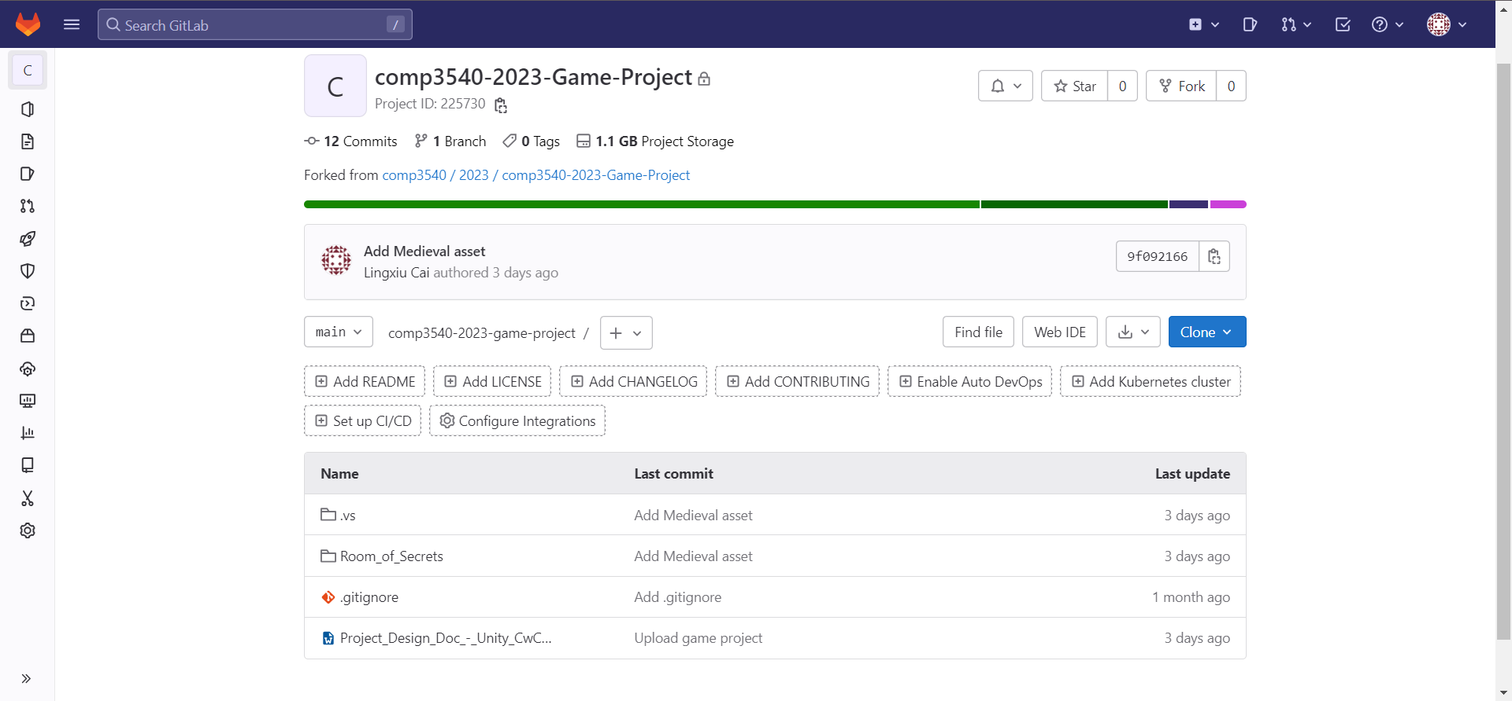

**Figure 1: Gitlab project**

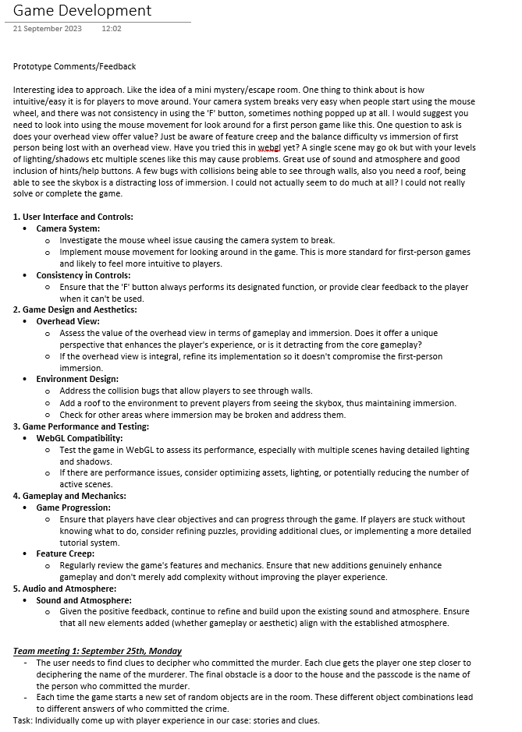

**Figure 2: Team meeting 1 record.**

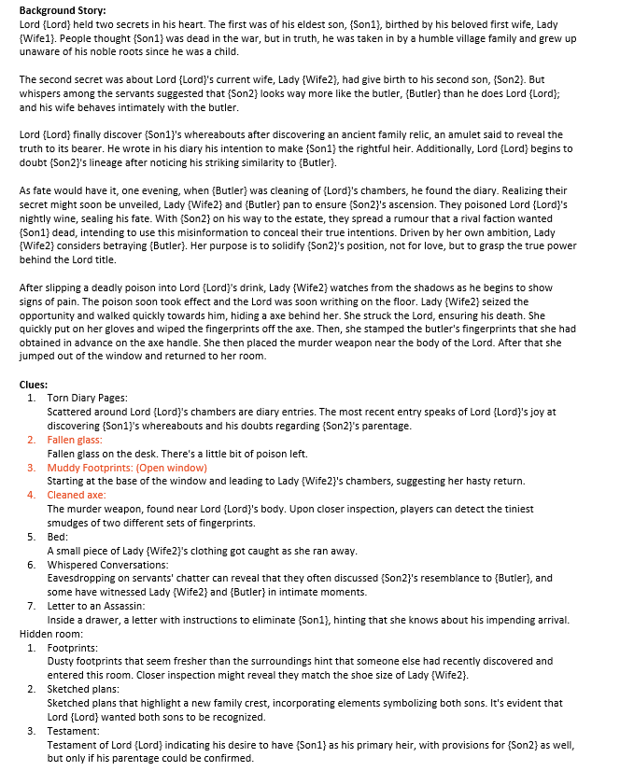

**Figure 3: Background story and clues design.**

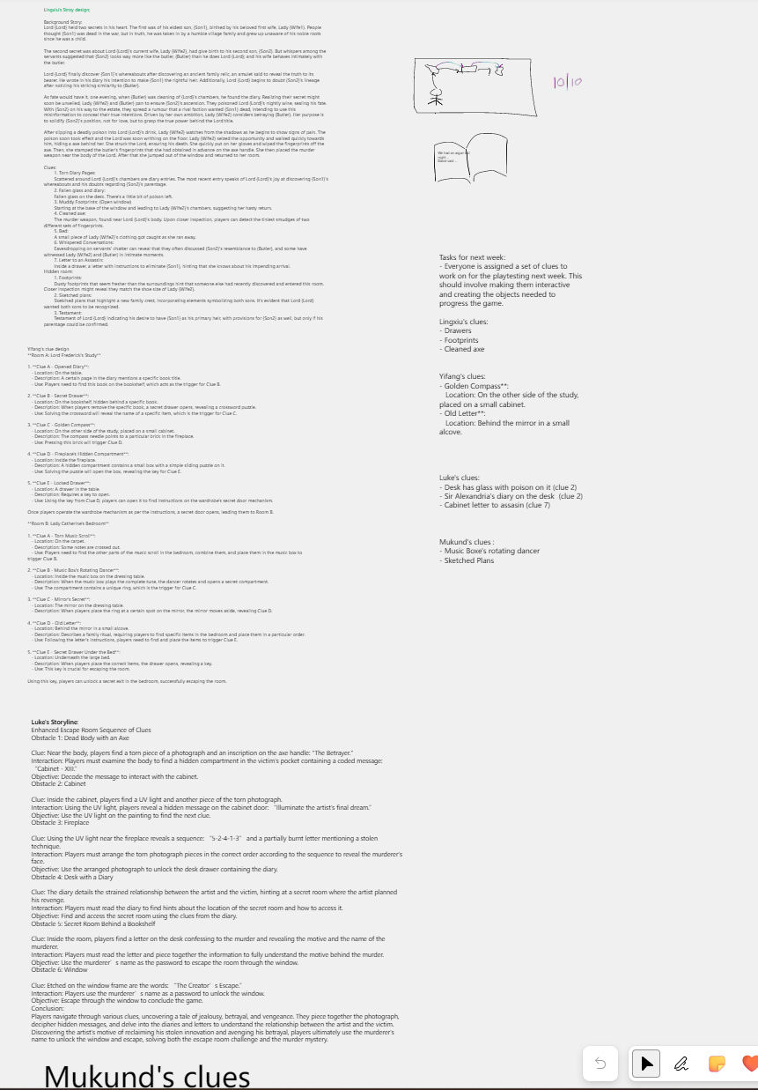

**Figure 4: Workshop meeting notes and task alignment.**